Rides
Each of our parks has a variety of rides to suit all ages–from our classic carousel with organ music and brass rings to our exhilarating roller coasters.
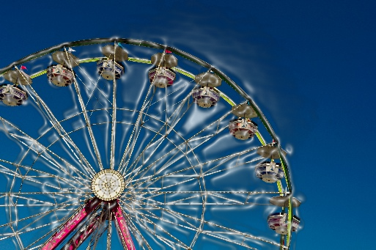
Here is a summary of our rides.
- Family Rides
- Kiddie Rides
- Roller Coasters
- Water Rides
There are plenty of benches for individuals choosing not to ride.
Some rides have height requirements.
Entertainment
We offer award-winning shows at all of our parks. Our resident entertainers provide professional stage shows. In addition, you will always find strolling groups of musicians and comedians throughout the park.
Food
All of our parks are known for both the variety and quality of food served. There are several different options in each park. Enjoy a relaxed meal in one of our full-service, air₋conditioned restaurants or the cafeteria.
If you are in a hurry or desire a snack, head to a food court. We offer tasty treats such as pizza, sandwiches, ice cream, and caramel corn.
Kosher, vegetarian, and reduced sugar options are available at all locations.
Theme Park FAQ
When to Visit:
Weekdays are ideal. Saturdays are usually our busiest day. To avoid standing in line to buy tickets, you can purchase them in advance.
Weather Tips:
When it is sunny, be sure to use sunscreen. If it rains, there is no need to leave. Wear a poncho, see a show, or go shopping. Sunscreen and ponchos are available for purchase in many of our stores.
Guest Services:
Visit our Guest Services office that is located immediately outside the entrance to the park. Our staff can assist you with the following services.
- Stroller rentals
- Child Finder Program
- Help guests with disabilities
- Park maps
Catering for Groups
More Comments
My wife and I appreciated the large number of kiddie rides for our 4 preschoolers. A. Berman
The stage show provided a cool place for us to relax in the heat of the day. Mary S.
The refillable souvenir cups are a great value. L. Purcell
The homemade potato chips served at all the park food venues are delicious. Be sure to try them! K. James
To get the most out of your visit, plan your day around the park’s entertainment schedule. John W.

We offer several venues in each park for your group event.
Food Options:
You can choose menus for a picnic lunch, a sit-down meal, or an allyou-care-to-eat buffet.
Bookings:
A twenty percent deposit is due at the time of booking. The balance is due the day of the event. Deposits are non-refundable and cancellations must be made a minimum of one week before the scheduled date to avoid a charge.
For more information or to book an event, contact Brenda Grove at (702) 555-6184.
Comments from Visitors
The coasters and water rides make it worth your while. D. Nesbitt

Magical Park Corporation
2417 Mountain Vista Court
Las Vegas, NV 89179
(702) 555-6184
OUR THEME PARKS
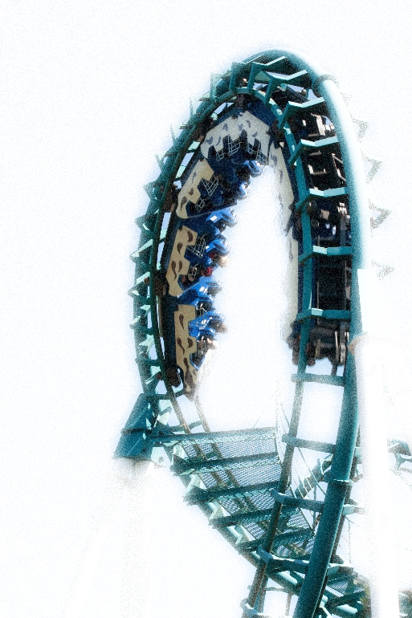
Fun for all ages!

